# GOVERNMENT POLYTECHNIC COLLEGE MATTANNUR-670702

### (Department of Technical Education, Kerala)



**SEMINAR REPORT ON**

**MAGLEV TRAIN**

**SUBMITTED BY NIKESH K**

**(Reg.No:19041665)**

**DEPARTMENT OF ELECTRONICS ENGINEERING**

**2021-22**

**GOVERNMENT POLYTECHNIC COLLEGE MATTANNUR-670702**

**(Department of Technical Education, Kerala)**



**CERTIFICATE**

*Certified that seminar work entitled* “***MAGLEV TRAIN*”***is a bonafide work carried out by* **“*NIKESH K* ”** *in partial fulfilment for the award of Diploma in Electronics Engineering from Government Polytechnic College Mattannur during the academic year* 2021-2022.

### Seminar Co-ordinator Head of Section

**Internal Examiner External Examiner**

**DECLARATION**

I hereby declare that the report of *the* ***MAGLEV TRAIN*** work entitled which is being submitted to the Govt. Polytechnic College Mattannur, in partial fulfilment of the requirement for the award **of *Diploma in Electronics Engineering*** *i*s a confide report of the work carried out by me. The material in this report has not been submitted to any institute for the award of any degree.

Place:Mattannur **NIKESH K**

### ACKNOWLEDGEMENT

I would like to take this opportunity to extend my sincere thanks to people who helped me to make this seminar possible. This seminar will be incomplete without mentioning all the people who helped me to make itreal.

Firstly, I would like to thank GOD, almighty, our supreme guide, for bestowing his blessings upon me in my entire endeavor.

I would like to express my deepest gratitude **Mr. M C PRAKASHAN** (Principal GPTC, Mattannur), **Mr. GEORGE KUTTY P P (**Head of Department of Electronics Engg.), for the help rendered by him to prepare and present this Seminar in proper way. Moreover I am very much indebted to **Mr. SREEJITH A** (Lecturer, Electronics Engg, seminar co-ordinator), for their advice.

I am also indebted to all my friends and classmates who have given valuable suggestion and encouragement.

**NIKESH K**

**ABSTRACT**

MAGLEV TRAIN accomplishes a research on the developing discipline of magnetic levitation and its application to transportation through trains. It provides detailed information about the evolution of maglev science, its progression and improvisation till date. Highspeed magnetically levitated ground transportation (maglev) is a new surface mode of transportation, in which vehicles glide above their guideways, suspended, guided, and propelled by magnetic forces. This report tries to explain the complexities involved in this technology in a simple but precise manner, so that all the methods implemented in it are understood by the reader at prima facie. Further, this helps us to learn about the various cities around the world, where maglev trains currently run and also provides an overview of the proposals for such trains, which are being considered as a promising investment globally. Consecutively, it deals with the accidents that have occurred at places where maglev trains have been implemented and the reasons that triggered them. This data has been included so that such incidents may be avoided in the future and in order that certain necessary modifications are made to improve the safety measures of these trains. Capable of travelling at speeds of 250 to 300 miles-per-hour or higher, maglev would offer an attractive and convenient alternative for travellers between large urban areas for trips of up to 600 miles. It would also help relieve current and projected air and highway congestion by substituting for shorthaul air trips, thus releasing capacity for more efficient long-haul service at crowded airports, and by diverting a portion of highway trips. Finally, our report gives a peek into the future expansions of maglev trains and thus undoubtedly assures its readers that maglev trains are no longer a science fiction, and are in fact the future of world transportation.

TABLE OF CONTENTS

**CHAPTERNO TOPICS PAGENO**

Chapter1 INTRODUCTION……………………………………...8

Chapter2 GENERAL OVERVIEW……………………………….9

Chapter3 MAGLEV : THE PRINCIPLE……………………..….10

Chapter4 TYPES OF MAGLEV MEHTOD..….. ………….……12

Chapter5 EVOLUTION OF MAGLEV………..….…………..…13

Chapter6 TECHNOLOGY AND WORING OF MAGLEV……..15

Chapter7 PROPULSION SYSTEM……………………………..17

Chapter8 MAGLEV THE BEST OPTION……………..……….19

Chapter8.1 FASTER TRIPS…………………………………….....19

Chapter8.2 HIGH RELIABILITY………………….………….…..19

Chapter8.3 PETROLIUM INDEPENDANCE……………...….….19

Chapter8.4 LESS POLLUTING…………………………………...19

Chapter8.5 HIGHER CAPACITY THAN AIR..……………….….19

Chapter8.6 HIGH SAFETY……...…………………….……….….19

Chapter8.7 CONVENIENCE……………………………………...20

Chapter8.8 IMRPOVED COMFORT………………………….….20

Chapter8.9 MAINTENACE…….…………………….…….….….20

Chapter9 ADVANTAGES AND DISADVANTAGES………....21

Chapter9.1 ADVANTAGES…………………………………….....21

Chapter9.2 DISADAVANTAGES………………….………….…..21

Chapter10 CONCLUSION………………………………………..22

Chapter11 REFERENCE………………………………………….23

|  |  |  |
| --- | --- | --- |
| **FIGURE NO** | **LIST OF FIGURES**  **NAME** | **PAGE NO** |
| Fig 3.1 | PRIMARY FUNCTION OF MAGLEV.... | 10 |
| Fig 5.1 | EVOLUTION OF MAGLEV TRAIN……….. | 13 |
| Fig 6.1 | INTERNAL WORKING OF MAGLEV…….. | 15 |
| Fig 7.1  Fig 7.2 | PROCESS OF PROPULSIONAND TRAVELLING FIELD………………………  REPLUSION OF MAGNETS……………… | 17  18 |

**CHAPTER 1**

**INTRODUCTION**

The term magnetic levitation has come to be used in a wide variety of different contexts ranging from suspending a small laboratory-scale stationary object so that it is isolated from vibrations of its surroundings (an isolation platform) to large-scale mobile applications such as maglev vehicles capable of carrying people and materials up to speeds of several hundred miles per hour or the proposed assisting in the launch of space vehicles. Depending on the nature of the application, some degree of physical contact may be required. However, if physical contact is to be completely eliminated, as in the case of very high-speed vehicles, then in addition to suspension, the functions of lateral guidance, propulsion, braking, energy transfer, and system control must be provided by noncontact means alone. Faced with a wide variety of options, maglev system designers must decide how the system should be configured and which components should be placed on board the vehicle and which should be mounted on the guideway. The decision depends on a variety of both technical and economic issues.

**CHAPTER 2**

**GENERAL OVERVIEW**

Transportation is the direct product of the social link and social relationship of the people. Revolutionary changes have taken place in the life of the mankind since human beings acquired the capability of walking upright as a result of evolution from the ape. Human being’s vision was widened to enable itself to better observe the surroundings and to be watchful against any possible crises. But due to the low productive forces and constraints on people by the conditions of the nature in the primitive times, usually they could not but live by hunting animals or gathering plants within a certain region to maintain the lease of life by making use of a few elements of the nature, let alone any act of transport for the commercial intercourse among the peasants, workers and merchants. Nevertheless, with the development of human society, people gradually widened their vision in the geographic space through several forms of lateral social contact in their production activities and injected active seeking factor into the passive man, environment relationship. Gradually, human being mastered the use of tools and other special at his service. Among others, the horse, an animal which changed the speed of human transportation, enabled a cart to run at some 10km/h, thus the region scoped varied and the link between city and city became closer, enhancing the progress of culture and civilization in various places.

**CHAPTER 3**

**MAGLEV : THE PRINCIPLE**

A method of supporting and transporting objects or vehicles which is based on the physical property that the force between two magnetized bodies is inversely proportional to their distance. By using this magnetic force to counterbalance the gravitational pull, a stable and contactless suspension between a magnet (magnetic body) and a fixed guideway (magnetized body) may be obtained. In magnetic levitation (Maglev), also known as magnetic suspension, this basic principle is used to suspend (or levitate) vehicles weighing 40 tons or more by generating a controlled magnetic force. By removing friction, these vehicles can travel at speeds higher than wheeled trains, with considerably improved propulsion efficiency (thrust energy/input energy) and reduced noise. In Maglev vehicles, chassis-mounted magnets are either suspended underneath a ferromagnetic guideway (track) or levitated above an aluminum track.

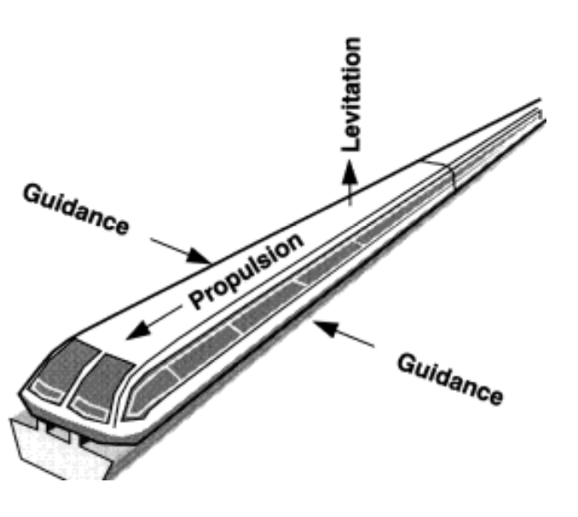

Fig 3.1 primary functions of maglev

Figure 3.1 depicts the three primary functions basic to Maglev technology:

(1) levitation or suspension;

(2) propulsion; and

(3) guidance

In most current designs, magnetic forces are used to perform all three functions, although a nonmagnetic source of propulsion could be used. No consensus exists on an optimum design to perform each of the primary functions.

In the attraction-type system, a magnet-guideway geometry is used to attract a direct-current electromagnet toward the track. This system, also known as the electromagnetic suspension (EMS) system, is suitable for low- and highspeed passenger-carrying vehicles and a wide range of magnetic bearings. The electromagnetic suspension system is inherently nonlinear and unstable, requiring an active feedback to maintain an upward lift force equal to the weight of the suspended magnet and its payload (vehicle).

In the repulsion-type system, also known as the electrodynamic levitation system (EDS or EDL), a superconducting coil operating in persistent-current mode is moved longitudinally along a conducting surface (an aluminum plate fixed on the ground and acting as the guideway) to induce circulating eddy currents in the aluminum plate. These eddy currents create a magnetic field which, by Lenz’s law, opposes the magnetic field generated by the travelling coil. This interaction produces a repulsion force on the moving coil. At lower speeds, this vertical force is not sufficient to lift the coil (and its payload), so supporting auxiliary wheels are needed until the net repulsion force is positive. The speed at which the net upward lift force is positive (critical speed) is dependent on the magnetic field in the airgap and payload, and is typically around 80 km/h (50 mi/h). To produce high flux from the traveling coils, hard superconductors (type II) with relatively high values of the critical field (the magnetic field strength of the coil at 0 K) are used to yield airgap flux densities of over 4 tesla. With this choice, the strong eddy-current induced magnetic field is rejected by the superconducting field, giving a self-stabilizing levitation Fig 1.1 Primary functions of Maglev 10 force at high speeds (though additional control circuitry is required for adequate damping and ride quality.

**CHAPTER 4**

**TYPES OF MAGLEV METHOD**

• Repulsion between like poles of permanent magnets or electromagnets.

• Repulsion between a magnet and a metallic conductor induced by relative motion.

• Repulsion between a metallic conductor and an AC electromagnet.

• Repulsion between a magnetic field and a diamagnetic substance.

• Repulsion between a magnet and a superconductor.

• Attraction between unlike poles of permanent magnets or electromagnets.

• Attraction between the open core of an electromagnetic solenoid and a piece of iron or a magnet.

• Attraction between a permanent magnet or electromagnet and a piece of iron.

• Attraction between an electromagnet and a piece of iron or a magnet, with sensors and active control of the current to the electromagnet used to maintain some distance between them.

• Repulsion between an electromagnet and a magnet, with sensors and active control of the current to the electromagnet used to maintain some distance between them.

**CHAPTER 5**

**EVOLUTION OF MAGLEV**

The goal of using magnets to achieve high speed travel with non-contact magnetically levitated vehicles is almost a century old. In the early 1900's, Bachelet in France and Goddard in the United States discuss the possibility of using magnetically levitated vehicles for high speed transport. However, they do not propose a practical way to achieve this goal.

On August 14, 1934, Hermann Kemper of Germany receives a patent for the magnetic levitation of trains. Research continues after World War II. In the 1970s and 1980s, development, commissioning, testing and implementation of various Maglev Train systems continues in Germany by Thyssen Henschel. The Germans name their Maglev system "Transrapid".

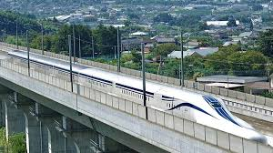

Fig 5.1 evolution of maglev train

In 1966, in the USA, James Powell and Gordon Danby propose the first practical system for magnetically levitated transport, using superconducting magnets located on moving vehicles to induce currents in normal aluminum loops on a guideway. The moving vehicles are automatically levitated and stabilized, both vertically and laterally, as they move along the guideway. The vehicles are magnetically propelled along the guideway by a small AC current in the guideway.

In 1992, the Federal Government in Germany decides to include the 300 km long superspeed Maglev system route Berlin-Hamburg in the 1992 Federal Transportation Master Plan.

In June of 1998, the US congress passes the Transportation Equity Act for the 21st Century (TEA 21). The law includes a Maglev deployment program allocating public funds for preliminary activities with regard to several projects and, later on, further funds for the design, engineering and construction of a selected project. For the fiscal years 1999 - 2001, $55 million are provided for the Maglev deployment program. An additional $950 million are budgeted for the actual construction of the first project. In November of 1999, the Chinese Ministry of Science and Technology and Transrapid International sign a letter of intent to select a suitable Transrapid route in the People's Republic of China and evaluate its technical and economic feasibility.

In January of 2001, in the US, Transportation Secretary Rodney Slater selects the Pittsburgh and the Washington - Baltimore routes for detailed environmental and project planning. Later that month in China, a contract is concluded between the city of Shanghai and the industrial consortium consisting of Siemens, ThyssenKrupp, and Transrapid International to realize 16 the Shanghai airport link. In March, the construction of the Shanghai project begins.

Currently, the original Powell-Danby Maglev inventions form the basis for the Maglev system in Japan, which is being demonstrated in Yamanashi Prefecture, Japan. Powell and Danby have subsequently developed new Maglev inventions that form the basis for their second generation M-2000 System. Other Maglev Train systems are in the planning and development stages in various cities in the US, including projects in Georgia, California and Pennsylvania.

In the future, Maglev promises to be the major new mode of transport for the 21st Century and beyond because of its energy efficiency, environmental benefits and time-saving high velocity transport. Because there is no mechanical contact between the vehicles and the guideway, speeds can be extremely high. Traveling in the atmosphere, air drag limits vehicles to speeds of about 300 - 350 mph. Traveling in low pressure tunnels, Maglev vehicles can operate at speeds of thousands of miles per hour. The energy efficiency of Maglev transport, either in kilowatt-hours per passenger mile for personal transport, or kilowatt hours per ton-mile for freight, is much lower for Maglev than for autos, trucks, and airplanes. It is pollution free, can use renewable energy sources such as solar and wind power, and in contrast to oil and gas fueled transport, does not contribute to global warming. It is weather independent, and can carry enormous traffic loads - both people and goods - on environmentally friendly, narrow guideways. The cost of moving people and goods by Maglev will be considerably less than by the present modes of auto, truck, rail, and air.

**CHAPTER 6**

**TECHNOLOGY AND WORKING OF MAGLEV**

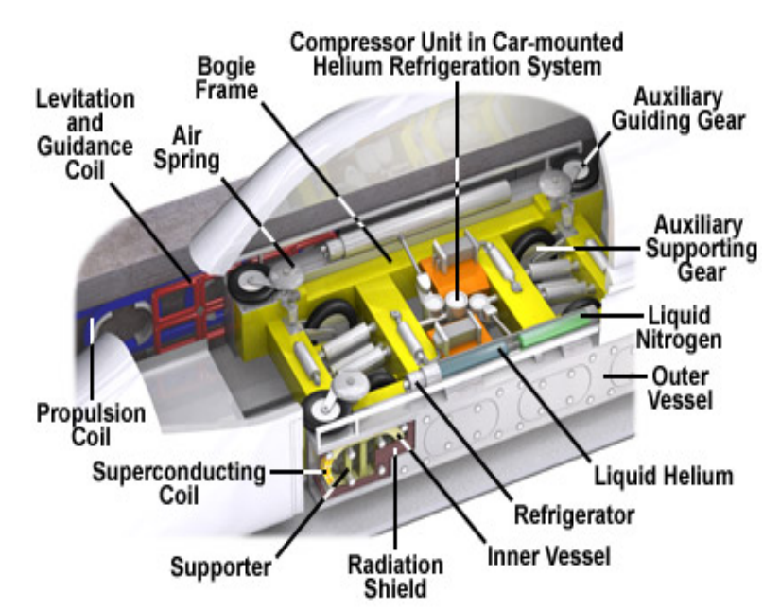

Fig 6.1 Internal woring of maglev trains

The Levitation System Support electromagnets built into the undercarriage and along the entire length of the train pull it up to the guideway electromagnets, which are called ferromagnetic reaction rails. The guidance magnets placed on each side of the train keep it centered along the track and guide the train along. All the electromagnets are controlled electronically in a precise manner. It ensures the train is always levitated at a distance of 8 to 10 mm from the guideway even when it isn't moving. This levitation system is powered by onboard batteries, which are charged up by the linear generator when the train travels. The generator consists of additional cable windings integrated in the levitation electromagnets. The induced current of the generator during driving uses the 18 propulsion magnetic field's harmonic waves, which are due to the side effects of the grooves of the long stator so the charging up process does not consume the useful propulsion magnetic field. The train can rely on this battery power for up to one hour without an external power source. The levitation system is independent from the propulsion system.

System Electronically controlled support magnets located on both sides along the entire length of the vehicle pull the vehicle up to the ferromagnetic stator packs mounted to the underside of the guideway. Guidance magnets located on both sides along the entire length of the vehicle keep the vehicle laterally on the track. Electronic systems guarantee that the clearance remains constant (nominally 10 mm). To hover, the Maglev requires less power than its air conditioning equipment. The levitation system is supplied from on-board batteries and thus independent of the propulsion system. The vehicle is capable of hovering up to one hour without external energy. While travelling, the on-board batteries are recharged by linear generators integrated into the support magnets.

**CHAPTER 7**

**PROPULSION SYSTEM**

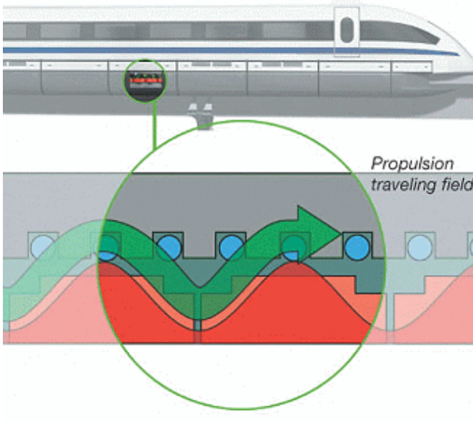

Fig 7.1 Process of propulsion and travelling field

The synchronous longstator linear motor of the Maglev maglev system is used both for propulsion and braking. It is functioning like a rotating electric motor whose stator is cut open and stretched along under the guideway. Inside the motor windings, alternating current is generating a magnetic traveling field which moves the vehicle without contact. The support magnets in the vehicle function as the excitation portion (rotor). The propulsion system in the guideway is activated only in the section where the vehicle actually runs.

The speed can be continuously regulated by varying the frequency of the alternating current. If the direction of the traveling field is reversed, the motor becomes a generator which brakes the vehicle without any contact. The braking energy can be re-used and fed back into the electrical network. The three-phase winded stator generates an electromagnetic travelling field and moves the train when it is supplied with an alternating current. The electronmagnetic field from the support electromagnets (rotor) pulls it along. The magnetic field direction and speed of the stator and the rotor are synchronized. The Maglev's speed can vary from standstill to full operating speed by simply adjusting the frequency of the alternating current. To bring the train to a full stop, the direction of the travelling field is reversed. Even during braking, there isn't any mechanical contact between the stator and the rotor. Instead of consuming energy, the Maglev system acts as a generator, converting the breaking energy into electricity, which can be used elsewhere.

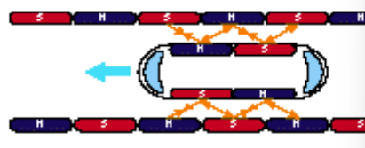

Fig 7.2 Repulsion of magnets

**CHAPTER 8**

**MAGLEV : THE BEST OPTION**

**8.1 Faster trips**

High peak speed and high acceleration/braking enable average speeds three to four times the national highway speed limit of 65 mph (30 m/s) and lower door-to-door trip time than high-speed rail or air (for trips under about 300 miles or 500 km).And still higher speeds are feasible. Maglev takes up where high-speed rail leaves off, permitting speeds of 250 to 300 mph (112 to 134 m/s) and higher.

**8.2 High reliability**

Less susceptible to congestion and weather conditions than air or highway. Variance from schedule can average less than one minute based on foreign high-speed rail experience. This means intra- and intermodal connecting times can be reduced to a few minutes (rather than the half-hour or more required with airlines and Amtrak at present) and that appointments can safely be scheduled without having to take delays into account.

**8.3 Petroleum independence**

With respect to air and auto as a result of being electrically powered. Petroleum is unnecessary for the production of electricity. In 1990, less than 5 percent of the Nation's electricity was derived from petroleum whereas the petroleum used by both the air and automobile modes comes primarily from foreign sources.

**8.4 Less polluting**

With respect to air and auto, again as a result of being electrically powered. Emissions can be controlled more effectively at the source of electric power generation than at the many points of consumption, such as with air and automobile usage.

**8.5 Higher capacity than air**

At least 12,000 passengers per hour in each direction with potential for even higher capacities at 3 to 4 minute headways. Provides sufficient capacity to accommodate traffic growth well into the twenty-first century and to provide an alternative to air and auto in the event of an oil availability crisis.

**8.6 High safety**

Both perceived and actual, based on foreign experience.

**8.7 Convenience**

Due to high frequency of service and the ability to serve central business districts, airports, and other major metropolitan area nodes.

**8.8 Improved comfort**

With respect to air due to greater roominess, which allows separate dining and conference areas with freedom to move around. Absence of air turbulence ensures a consistently smooth ride.

**8.9 Maintenance**

Due to the non-contact technology, the cost of vehicle and guideway maintenance is very low. In the event of a malfunction of one of the propulsion and control components, the remaining components can assume its responsibilities, thereby ensuring a high overall system availability. If an electronic component group in the vehicle fails, the high redundancy concept guarantees that the vehicle will reach the next destination.

**CHAPTER 9**

**ADVANTAGES AND DISADVANTAGES**

**9.1 Advantages:**

* Extremely fast speed upto 500 km/hr.
* Really quiet operation. A farmer couldn't hear when the train was passing.
* MagLevs uses less energy upto 30% than normal trains.
* Due to lack of physical contact between train and track, very efficient for maintenance.
* Sexy new technology. If you want to appear to have the most advanced technology, having a maglev train will definitely help.

**9.2 Disadvantages:**

* Expensive to build, not least because it’s a new and largely untried technology.
* Expensive to operate, both to maintain the new technology and because the energy consumption is quite high.
* Not necessarily any faster than a high speed wheel on rail.
* Not necessarily quieter than high speed wheel on rail (and noise is an issue for high speed rail)
* Not immune from the problems of needing a straight route with shallow bends.
* Unsuitable for heavy freight (as is high speed wheel on rail), and freight and passenger traffic cannot share the same lines at all (wheel on rail can, though it screws up the high speed train’s track utilisation by blocking the track for longer).

**CHAPTER 10**

**CONCLUSION**

This report gives us an insight about the principle of maglev as well as its application in running maglev trains. Also, the intricate complexities of the maglev technology have been explained. Its implementation in the various cities of the world and its innumerable advantages just take it a step closer to being the future of transportation. Maglev trains are soon going to be the new way of transportation. Just a few obstacles are in the way, but with some more improvisations nothing is impossible. With no engine, no wheels, no pollution, new source of energy, floating on air, the concept has taken tens of years to develop and just recently its true capabilities have been realized. Competing planes with speed, ships with efficiency, traditional trains with safety, and cars with comfort, it seems like a promising means of transport. Maglev trains are environment friendly; noise pollution is minimized because there is no wheel to rail contact (frictionless). A maglev train operating at 150mph is inaudible to a person standing 25 miles away. The system encourages land conservation, which is especially useful where land is costly or unavailable. Tracks for the trains are easily built on elevated platforms; this provides opportunity for construction and development underneath and prevents land dissection and also reduces animal collisions. This assertion can prove useful in constructing guide ways for maglev trains across residential areas, schools, religious places, tourist spots, etc. However, the cost of construction of these trains runs into billions of dollars. The high cost of these trains is the only deterrent factor which is preventing the train from being executed everywhere. Continued research in this field along with active interest from the various governments in the world can reduce the costing considerably with cheaper options not compromising on the safety.

**CHAPTER 11**

**REFERNCE**

• [www.hk-phy.org/articles/maglev/maglev_e.html](http://www.hk-phy.org/articles/maglev/maglev_e.html)

• [www.gluckman.com/Maglev.html](http://www.gluckman.com/Maglev.html)

• [www.o-keating.com/hsr/maglev.htm](http://www.o-keating.com/hsr/maglev.htm)

• [www.calpoly.edu/~cm/studpage/clottich/phys.html](http://www.calpoly.edu/~cm/studpage/clottich/phys.html)

• [www.sasked.gov.sk.ca/docs/physics/u7c3phy.html](http://www.sasked.gov.sk.ca/docs/physics/u7c3phy.html)

• [www.tonmeister.ca/main/textbook/electronics/07.html](http://www.tonmeister.ca/main/textbook/electronics/07.html)

• [www.techtv.com/news/culture/story/](http://www.techtv.com/news/culture/story/)